**Tasks**

The visualization, titled "Number of Unauthorized Immigrants and Their Share of the Population in Each State" is designed to support several comparative and informative tasks:

**State-wise Comparison:** It facilitates a direct comparison between states in terms of the total number of unauthorized immigrants and their share of the state's total population, highlighting disparities.

**Identify Concentration:** The plot allows viewers to identify states with high concentrations of unauthorized immigrants, with a specific focus on the magnitude (through the number of unauthorized immigrants) and the relative impact (through their share of the population).

**Logarithmic Analysis:** By using the logarithm of the number of unauthorized immigrants, the visualization ensures that the data's wide range is manageable and comparisons are easier to make, particularly for states with large numbers.

**Pattern Recognition:** Observers can recognize patterns of distribution among the states, such as the significant concentration of unauthorized immigrants in certain states like California and Texas, versus the majority of states clustered with lower values.

This visualization equips viewers with a clearer understanding of the relationship between unauthorized immigration and specific industries, facilitating informed discourse on labor and immigration policies by emphasizing the industries most influenced by unauthorized workers.

**Data**

**Source:** The data for this scatter plot was sourced from the Migration Policy Institute (MPI) analysis of U.S. Census Bureau data from the 2015-19 American Community Survey (ACS) pooled, and the 2008 Survey of Income and Program Participation (SIPP). This analysis uses a methodology developed in consultation with James Bachmeier of Temple University and Jennifer Van Hook of The Pennsylvania State University, Population Research Institute.

Concerns and Processing: No

**Design process**

Originally, I decided to draw a map like picture 1 to show the Unauthorized Immigrants Share of the Population in Each State.

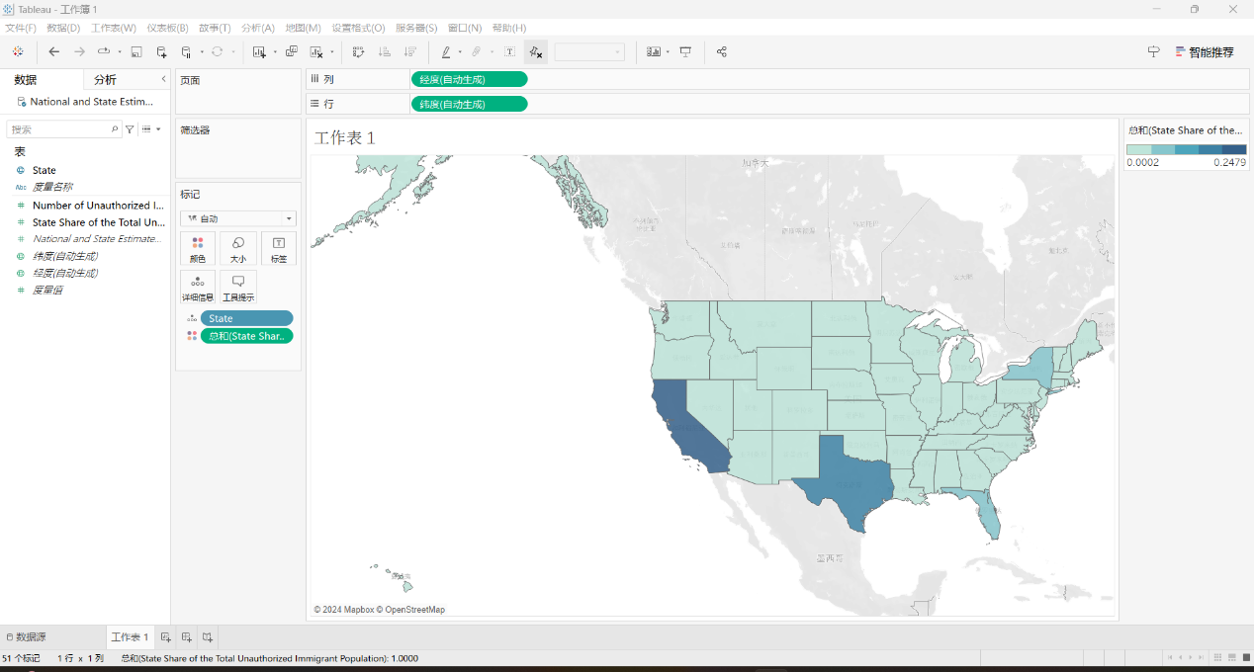

But I found that this can only show very limited information, so I decided to use a scatter plot.

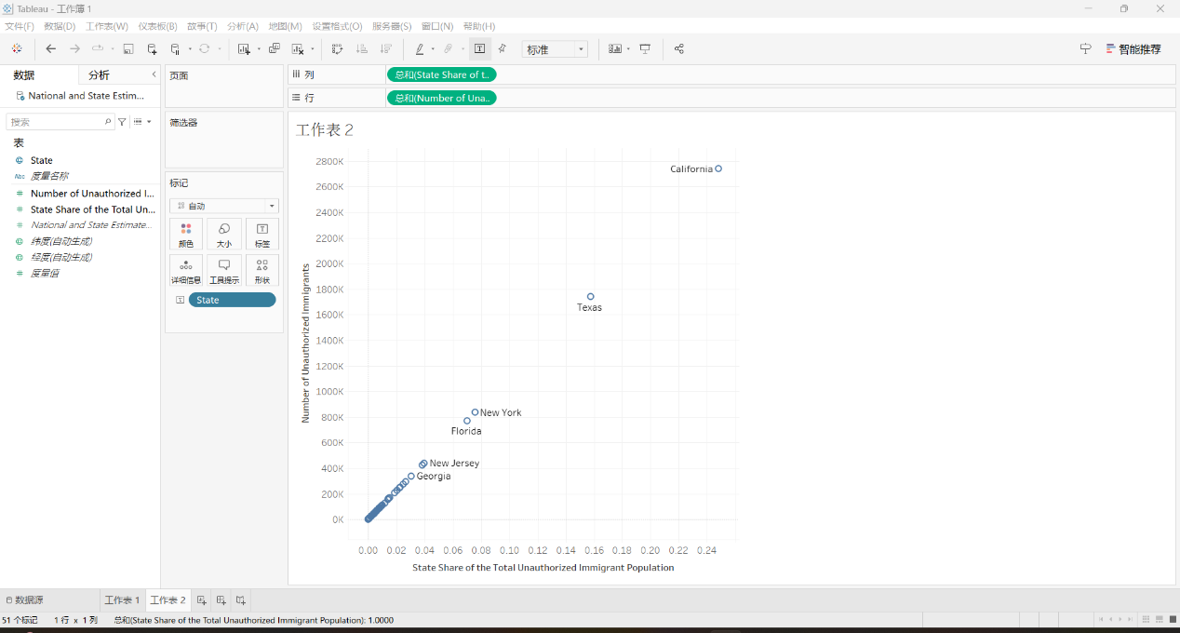

Now I found that the Number of Unauthorized Immigrants for each state is too large, and most cities are gathering in the lower left corner of the picture. Therefore, I decided to take lg function on the y-axis and do some picture beautification to get the final version.

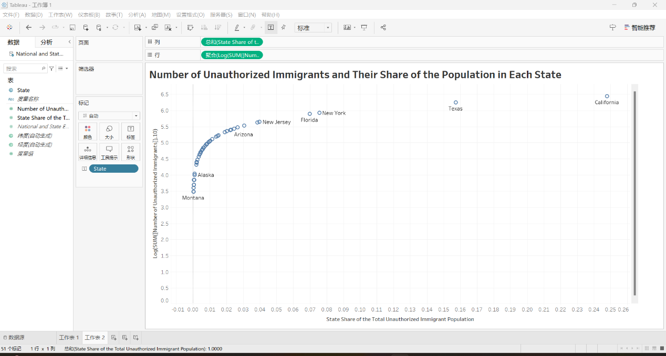

**Qualitative self-evaluation**

**Evaluation:** My scatter plot visualization effectively demonstrates the distribution of unauthorized immigrants across states, employing logarithmic scaling to manage the wide data range and enhance readability, reflecting Tufte's principle of data integrity and clear presentation.

**Effectiveness:** The plot's design facilitates easy comparison and pattern recognition, directly aligning with the principle of presenting complex information clearly and efficiently, allowing viewers to discern trends in immigration data.

**Improvement Areas:** While the visualization successfully conveys the intended message, incorporating interactivity could improve user engagement and understanding, offering a deeper exploration of the data.

**Class Principles Connection:** This design reflects class principles emphasizing clarity, precision, and the importance of efficient data representation. Future iterations could benefit from further reducing non-data ink and exploring alternative visualization methods to accommodate diverse data aspects.